TASK | General parts lubrication on fork lift truck
LOCATION OF USE | Workshop and field engineers |  | Assessment  No |  | 011
PRODUCT NAME | Multilube |  |  |  | 011
DESCRIPTION OF SUBSTANCE | Aerosol containing universal lubricant |  |  |  | 011
MANUFACTURER | SEH Logistics |  |  |  | 011
MANUFACTURERS CONTACT | Unit FFB 9  Bonehill Farm  Tamworth  Staffordshire. B78 3HP  Tel: 07725 041331 |  |  |  | 011
ASSESSOR | Martin Monaghan CMIOSH |  | Date |  | 23 07 24
TITLE | Health and Safety Consultant |  | Review by |  | 23 07 26
Personnel Performing Task  (Please list below)  Technicians/ Fitters/ Workshop Operatives |  | Time Spent  (Minutes/day)  As and when required, amounting to a few minutes per day | Training Given 
 |  |  | Yes

MSDS Revision Date | Hazard Statement
04/07/2014 Rev:1 | Not Classified

Assessment to be conducted in Association with Hazard Data Sheets, a full current copy of which must be attached to this assessment.

Please denote the hazardous properties of the substances used in the task with a

NEW INTERNATIONAL GLOBALLY HARMONISED HAZARD SYMBOLS
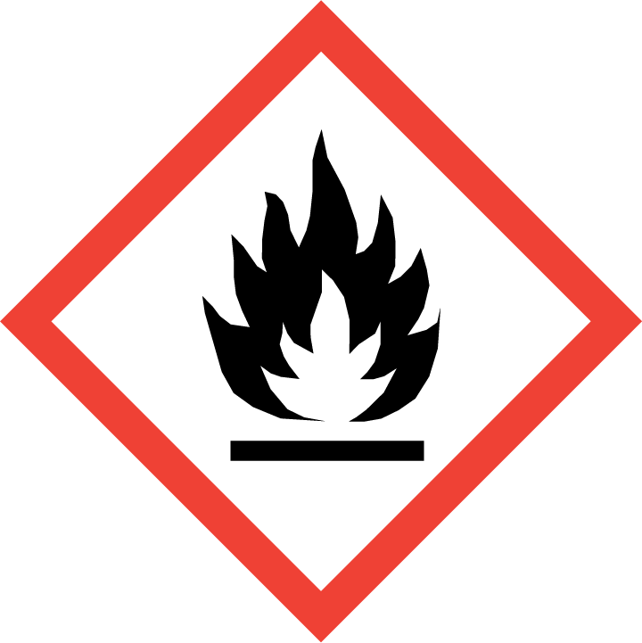 | 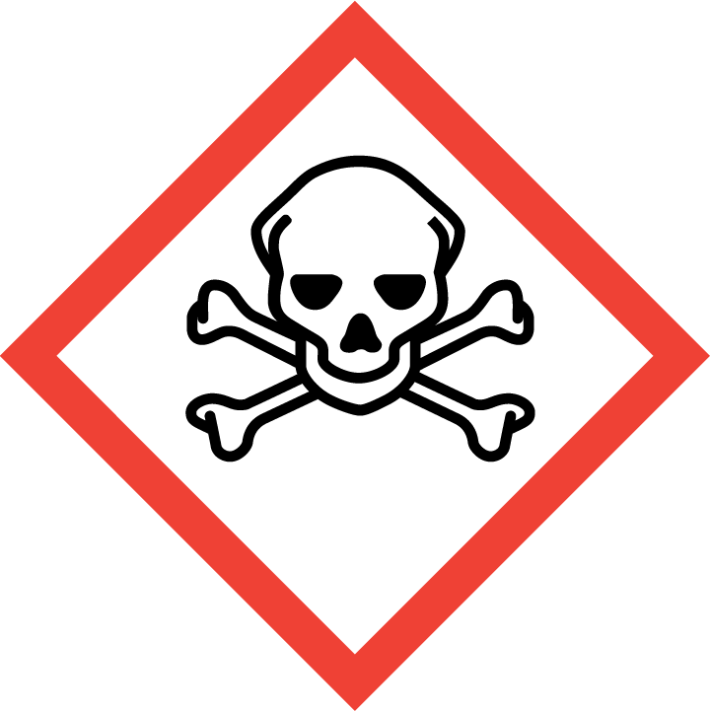 | 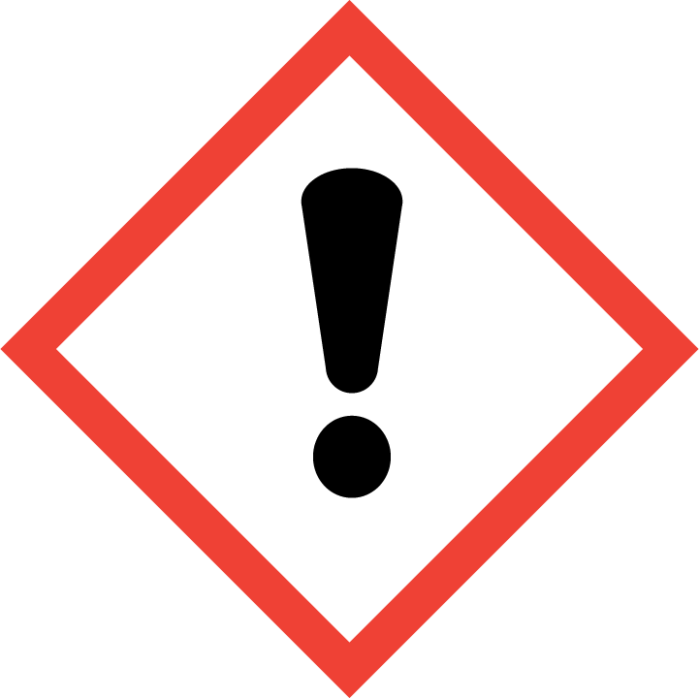 | 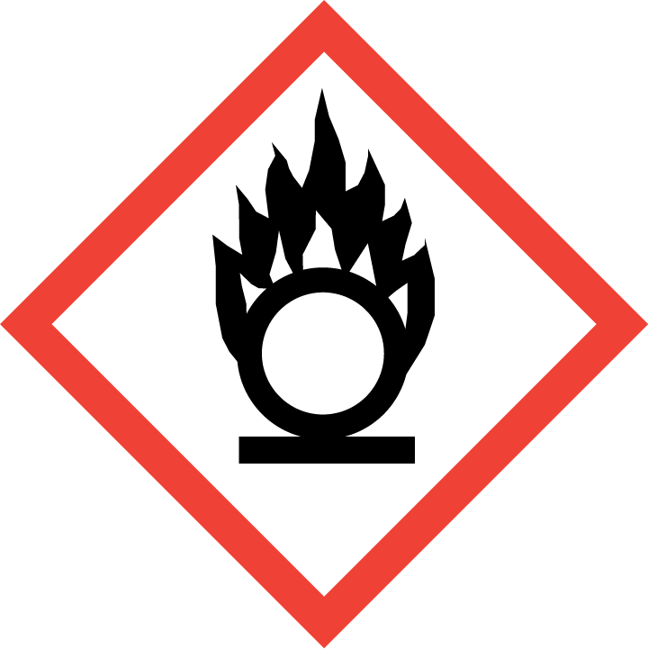 | 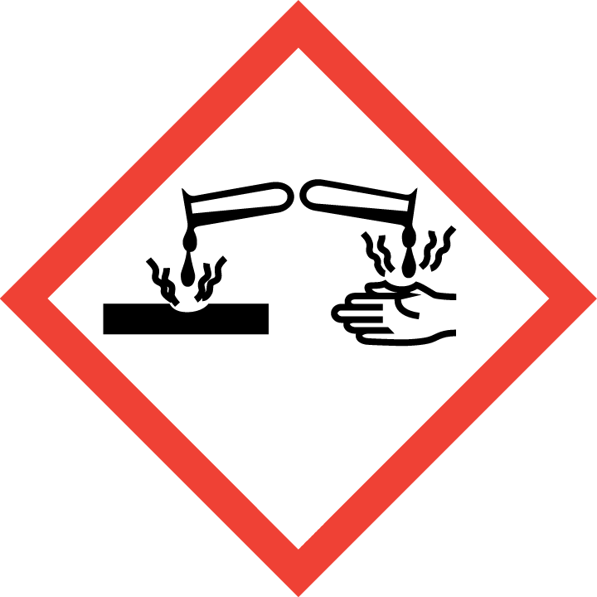 | 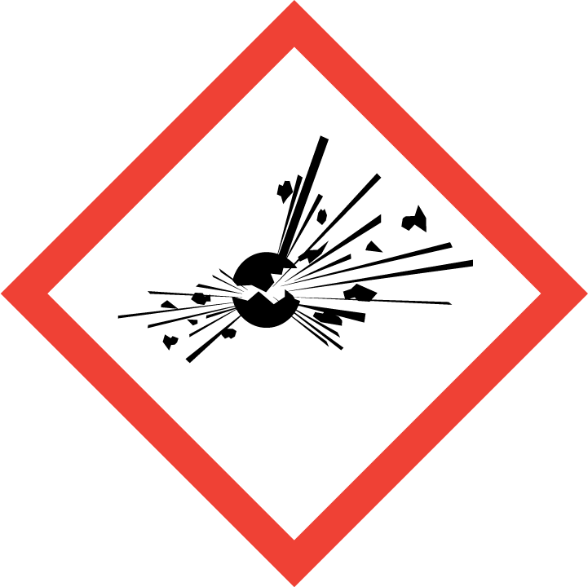 | 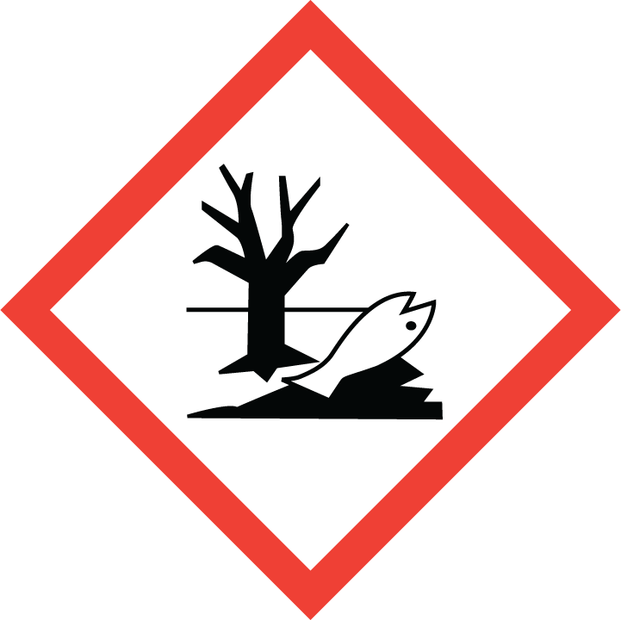 | 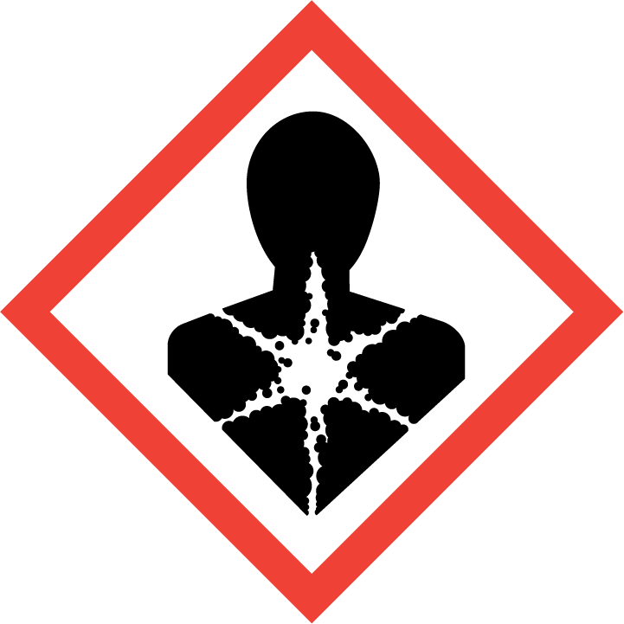
Flammable | Toxic | Harmful | Oxidising | Corrosive | Explosive | Harmful to the environment | Health Hazards i.e. respiratory sensitisation or carcinogenicity

SMOKING, EATING AND DRINKING ARE PROHIBITED IN THE WORK AREAS.
Information, Instruction and Training must be provided to all users. Young Persons, New or Expectant Mothers and other vulnerable groups must not use or be exposed to this product.

WORKPLACE EXPOSURE LIMITS (WEL’s)
No occupational exposure limits assigned for this product.

IMPORTANT!
Refer to Workplace Exposure Levels information provided in the Manufacturers Safety Data and revise control measures if exposure levels likely to be reached.

ROUTE OF EXPOSURE
Skin |  | Eyes |  | Inhalation
Ingestion |  | Cuts/abrasions |  | Systemic

PERSONS AT RISK
User of product |  | Co workers |  | Members of the public

ROUTE OF EXPOSURE |   FIRST AID MEASURES
Inhalation | If spray/mist has been inhaled, proceed as follows. Move affected person to fresh air and keep warm and at rest in a position comfortable for breathing. If breathing stops, provide artificial respiration. Keep the affected person warm and at rest. Get prompt medical attention.
Ingestion | Rinse mouth thoroughly with water. DO NOT induce vomiting. Get medical attention immediately.
Skin contact | Remove contaminated clothing immediately and wash skin with soap and water.
Eye contact | Rinse immediately with plenty of water. Remove any contact lenses and open eyelids wide apart. Continue to rinse for at least 15 minutes. Continue to rinse for at least 15 minutes and get medical attention.
In all cases of doubt, or if symptoms persist seek medical attention. Never give anything by mouth to an unconscious person. If unconscious, place in recovery position and seek medical advice.

PERSONAL PROTECTIVE EQUIPMENT
 |  |  |  | 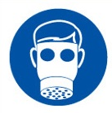 |  | 
YES | YES | YES/NO |  | YES/NO | YES | YES/NO
YES | YES |  |  |  | YES -

HANDLING | STORAGE | TRANSPORT | DISPOSAL
Keep away from heat, sparks and open flame. Eliminate all sources of ignition. Do not spray on a naked flame or any incandescent material. | Aerosol cans must not be exposed to direct sunlight or temperatures exceeding 50ºC. Store in flammable store when at factory. | Only carry minimum required amounts at any one time. Carry secured upright within the vehicle away from direct sunlight and sources of ignition. | Dispose of waste and residues in accordance with local authority requirements. Return empty aerosols to the factory for correct disposal.

REQUIRED CONTROL MEASURES
Ensure only minimum amounts are transported and used (1 can).
Ensure approved impermeable gloves are used at all times.
Ensure overalls are worn and these are suitably laundered.
Ensure suitable chemical resistant goggles are worn when spraying Multilube.
Ensure that work is undertaken in well ventilated areas, where significant spray is required ensure a suitable vapour/particle respirator is used.
Do not apply near walkways and clear any areas of overspray.
Ensure that Engineers are equipped with antibacterial hand washes and wipes and that good hygiene practices are enforced.
Provide suitable barrier creams.
Ensure that the aerosol is always used with the straw attachment to reduce the risk of overspray.
Do not apply near heat sources or sources of ignition.

FIRE PRECAUTIONS
Extinguish with foam, carbon dioxide, dry powder or water fog.

ACCIDENTAL RELEASE/SPILLAGE PROCEDURES
Provide adequate ventilation. Use suitable respiratory protection if ventilation is inadequate. Avoid inhalation of vapours

MONITORING REQUIREMENTS AND HEALTH SURVEILLANCE
Health surveillance is not in place for workers exposed to this product.

